

Operating Systems

Samjhana Dahal
Bsc (Hons) Computer Science with Artificial Intelligence
Softwarica College of IT and E-commerce ST5003CMD
Operating Systems, Security, and Networks
Rupak Rajbanshi
18th September 2026

Table Of Contents
1. Introduction 2
2. Creating the Source File 2
3. Open the File in Editor 2
4. Display File Contents 3
5. Compilation Process 3
5.1 Preprocessing 3
5.2 Compilation to Assembly 3
5.3 Viewing Assembly 4
5.4 Compile to Object File 6
5.6 Link Executable 7
5.7 Run Program 7

Table Of Figures

Figure 1 : Creating and listing the file sam.c. 2
Figure 2: Writing a simple C program using nano editor. 2
Figure 3: Source code of the C program written in sam.c. 3
Figure 4: Preprocessing stage generating sam.i file. Compilation to Assembly 3
Figure 5: Compilation stage generating sam.s file. 4
Figure 6: Assembly code output showing translation of C program. 6
Figure 7: Object file creation. 7
Figure 8: Linking object file to executable. 7
Figure 9: Run program 7

1. Introduction
This report demonstrates the process of creating, compiling, and executing a simple C program using GCC in a Linux environment

2. Creating the Source File
touch sam.c → Creates an empty file.
ls → Shows the file in the directory.

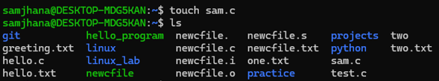
Figure 1 : Creating and listing the file sam.c.

3. Open the File in Editor
Opens the file in the nano text editor so you can write code inside it.
Figure 2: Writing a simple C program using nano editor.

4. Display File Contents
Print the contents of the file sam.c directly in the terminal.
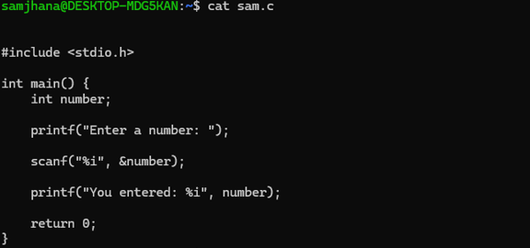
Figure 3: Source code of the C program written in sam.c.

5. Compilation Process

5.1 Preprocessing
Runs the preprocessor, expands macros, and saves output in sam.i.
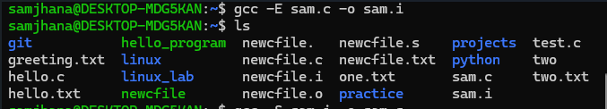
Figure 4: Preprocessing stage generating sam.i file. Compilation to Assembly

5.2 Compilation to Assembly
Compiles the preprocessed file (sam.i) into assembly code (sam.s).

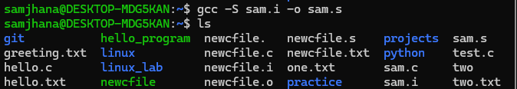
Figure 5: Compilation stage generating sam.s file.

5.3 Viewing Assembly
Displays the assembly code generated from the C program.
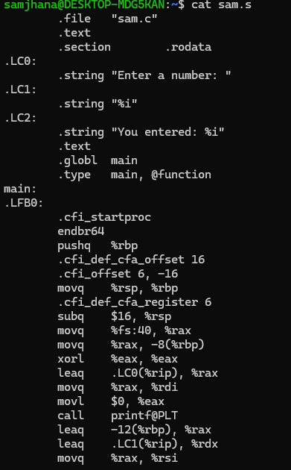
zzz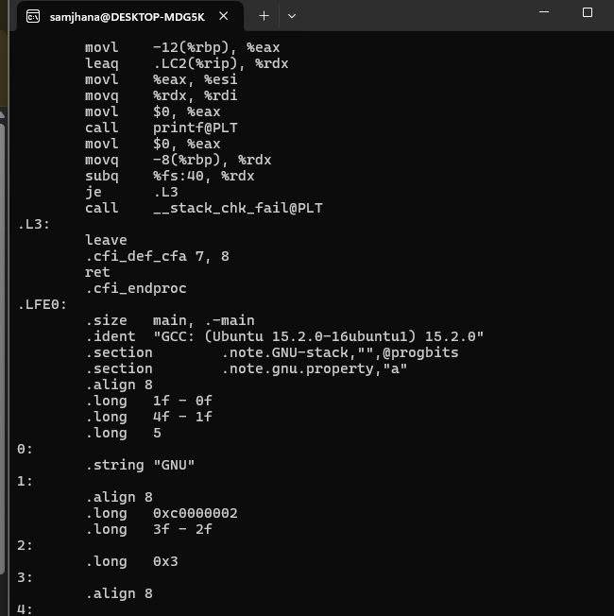
Figure 6: Assembly code output showing translation of C program.

5.4 Compile to Object File
Compiles assembly into an object file (sam.o).
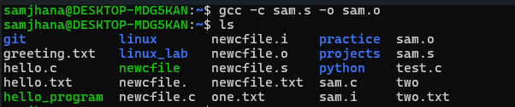
Figure 7: Object file creation.

5.6 Link Executable
Links the object file to create the executable (sam).
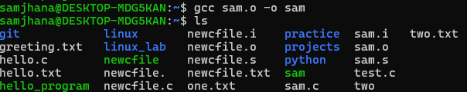
Figure 8: Linking object file to executable.

5.7 Run Program
Executes the program, asks for input, and displays output.

Figure 9: Run program

